**Computer Networks 1**

**Lab 1**

# Network Devices

Student Name: Nguyễn Hữu Hiếu Student No.: 2013149

**I. Objectives:**

* Get to know basic network devices
* Understand functions of network devices
* Able to connect different network devices together to form a simple network

**II. Content**

1. **Get to know network devices:**

Network Interface Card (NIC)

* + Cables
  + Hub
  + Switches
  + Routers
  + Access Points
  + Modems

1. **Understanding functions of network devices**

## a. Network Interface Card (NIC)

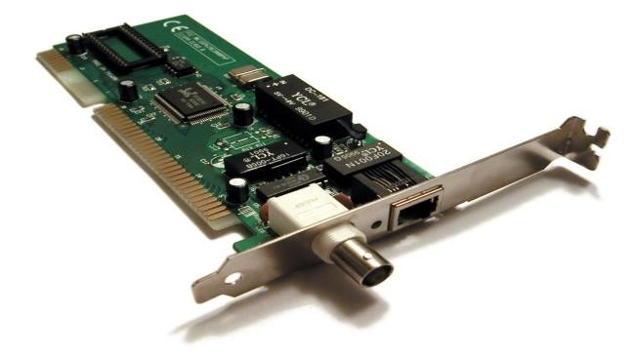

*NIC functions*: is a hardware component that connects a computer to network.

*Code of NIC processors*: are programmable processors that can execute software code to perform various network-related tasks.

*Check NIC of a computer, what is its MAC address?*

*The MAC address* is a unique idenrifier assigned to a network interface controller (NIC) for use a network address in communications within a network segment.

*Cable to connect NIC to a network:*

Type: Ethernet cable

Standard: Category 5 (Cat 5)

**b. Hub**

**s**

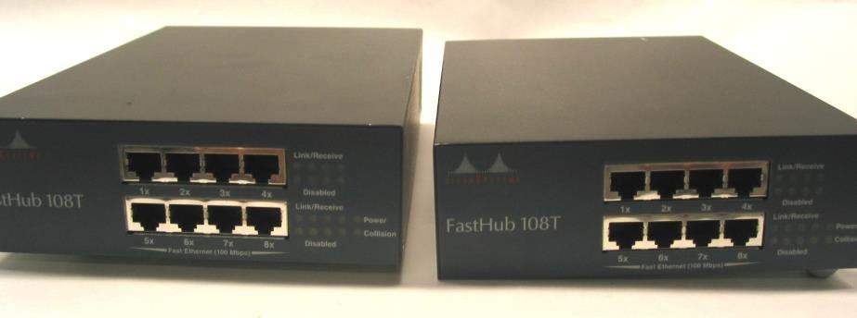

*Roles of hub in a network:* Hub is used to connect multiple devices in a network together. Its main role in a network is to receive incoming data packets from one device and broadcast them to all the other connected devices.

*Main characteristics:* Physical Layer Device; Broadcasting; Signal Amplification; Limited Intelligence: Unmanaged; Shared Bandwidth; Low Cost.

*Weaknesses of hub:*

* Broadcasts to All devices: When a hub receives a data packet, it broadcasts it to all devices connected to it, regardless of whether the device is the intended recipient. This can result in network congestion, as all devices on the network must process the packet, even if it is not intended for them.
* Limited Bandwidth: Hubs typically have limited bandwidth and can become quickly overwhelmed as more devices are added to the network. As a result, network performance can suffer, particularly in larger, more complex networks.
* Unmanaged: Hubs are typically unmanaged devices, which means that they do not have a user interface or any advanced configuration options. This can make it difficult to troubleshoot network issues or make changes to the network configuration.

*Hub ports*: A hub typically has multiple ports that are used to connect network devices, such as computers, printers, and other networking equipment. Each port on a hub is used to connect a single device to the network. Hubs can have different numbers of ports, depending on the model and manufacturer*.*

## c. Switches

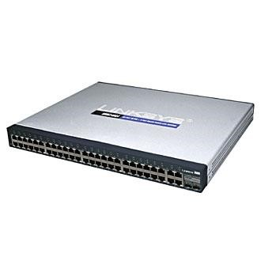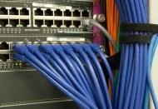

*Roles of switches in a network:* Switches are essential networking devices that play a critical role in the operation of modern computer networks.

*Main characteristics of switches*: Filtering and Forwarding; Ports; Management and Monitoring; Quality of Service (QoS); Security

*Differences between hubs and switches:*

* Packet Forwarding: Hubs broadcast incoming network traffic to all connected devices, whereas switches selectively forward traffic only to the device that it is intended for. This means that switches are more efficient and secure compared to hubs
* Collision Domain: Hubs create a single collision domain for all connected devices, whereas switches create a separate collision domain for each connected device. This means that switches are better able to manage network traffic and prevent network congestion compared to hubs.
* Bandwidth: Hubs share the total bandwidth of the network among all connected devices, whereas switches provide dedicated bandwidth to each connected device. This means that switches offer better network performance compared to hubs.
* Security: Hubs provide no security features, whereas switches can offer features such as VLANs (Virtual Local Area Networks) and port security, which can limit access to network devices based on their MAC address.
* Management and Monitoring: Hubs cannot be managed or monitored, whereas switches can be managed and monitored using software tools that allow network administrators to monitor network traffic, configure network settings, and troubleshoot network issues.

*Weaknesses of switches:*

* Cost: switches are generally more expensive compared to hubs, which can be a disadvantage for small businesses or home networks with a limited budget.
* Complexity: Switches can be more complex to configure and manage compared to hubs, which can be a disadvantage for users with limited networking experience.
* Limited Ports: Switches come with a limited number of ports, which can be a disadvantage for large networks that require many connections.

*Switch ports:* Switches have multiple ports that are used to connect devices to the network. Each port on a switch is a connection point for a network cable that allows a device to communicate with other devices on the network.

## d. Routers

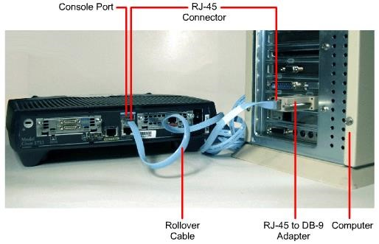

*Roles of routers in a network:* Routers play a key role in connecting multiple networks together and directing traffic between them

*Main characteristics of routers:* Network layer connectivity; Routing and forwarding; Security and access control; Network address translation (NAT) ;Quality of service (QoS)

*Differences between routers and switches:*

* Function: Routers are used to connect multiple networks together and direct traffic between them, while switches are used to connect devices within a network and direct traffic between them.
* Network layer: Routers operate at the network layer of the OSI model and use IP addresses to forward packets between networks, while switches operate at the data link layer and use MAC addresses to direct traffic within a network.
* Cost: Routers are generally more expensive than switches due to their more advanced functionality and higher level of complexity.
* Port types: Routers typically have fewer ports than switches and may have a combination of WAN and LAN ports. Switches can have many more ports and are often used to connect end-user devices such as computers and printers.

*Router ports:* Routers typically have several types of ports that allow them to connect to different networks and devices.

* WAN port
* LAN port
* USB port
* Console port
* Management port
* VoIP port

## d. Access Points

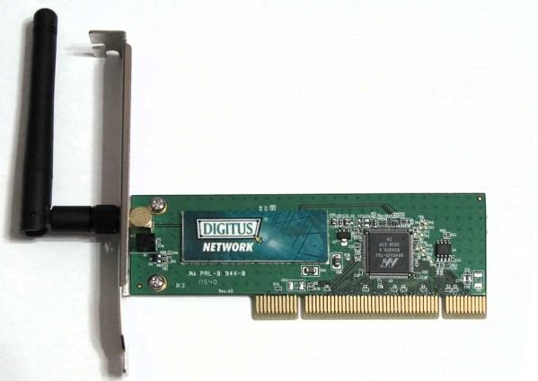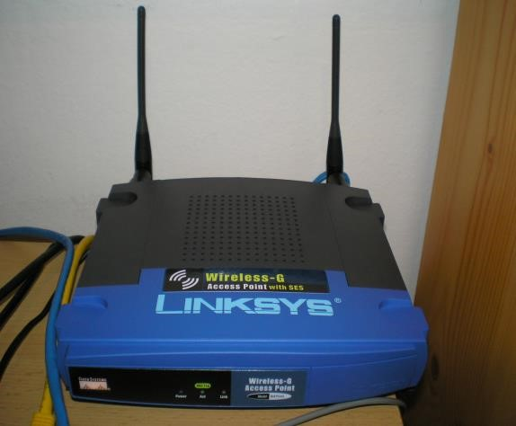

*Roles of access points*: is a device that allows wireless devices to connect to a wired network using Wi-Fi

*Main characteristics of access points*: Wireless connectivity; Network coverage; Speed and bandwidth; Security features; Compatibility; Scalability.

Access point’s interfaces:

* Ethernet interface: This interface is used to connect the access point to a wired network, allowing it to provide wireless connectivity to the network.
* Console interface: This interface is used for local configuration and management of the access point using a console cable and a computer terminal.
* USB interface: This interface is used to connect USB devices to the access point, such as a 3G or 4G modem, which can be used as a backup connection in case the wired network fails.
* Power interface: This interface is used to connect the access point to a power source, such as a power adapter or a Power over Ethernet (PoE) switch, which provides both power and data to the access point through a single Ethernet cable.
* Reset button: This button is used to reset the access point to its default settings, which can be helpful in troubleshooting or configuring the access point.
* Antenna connectors: Access points may have one or more antenna connectors, which are used to connect external antennas to the access point to improve wireless coverage or signal strength.

*Compare access point and other networking devices mentioned above:*

* Access point vs. hub: An access point provides wireless connectivity to devices using Wi-Fi, while a hub is a simple networking device that connects multiple devices in a network but does not manage network traffic. Access points have limited coverage areas, while hubs have no coverage limitations. Access points support security features such as encryption and authentication, while hubs have no security features.
* Access point vs. switch: An access point provides wireless connectivity to devices using Wi-Fi, while a switch connects multiple devices in a network and manages network traffic. Access points have limited coverage areas, while switches have no coverage limitations. Access points support security features such as encryption and authentication, while switches have basic security features. Access points have wireless interfaces, while switches have wired interfaces.
* Access point vs. router: An access point provides wireless connectivity to devices using Wi-Fi, while a router connects multiple networks and manages network traffic between them. Access points have limited coverage areas, while routers have no coverage limitations. Access points support security features such as encryption and authentication, while routers have advanced security features. Access points have wireless interfaces, while routers have both wired and wireless interfaces.
* Access point vs. NIC: An access point provides wireless connectivity to devices using Wi-Fi, while a NIC connects a device to a network using a wired connection. Access points have limited coverage areas, while NICs have no coverage limitations. Access points support security features such as encryption and authentication, while NICs have no security features. Access points have wireless interfaces, while NICs have wired interfaces.

## e. Modem

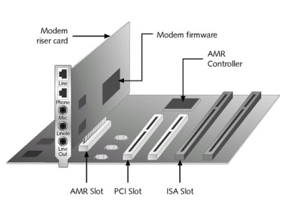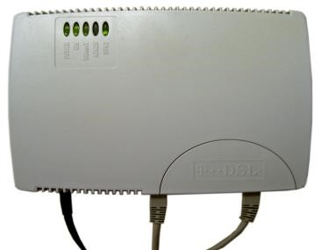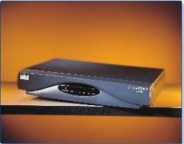

Differentiate:

* Dial-up modem : A dial-up modem is a type of modem that uses a telephone line to establish a connection to the Internet. It converts the digital data of a computer into analog signals that can be transmitted over a telephone line

Characteristics:

* Speed: Dial-up modems typically have speeds of up to 56 kbps, which is much slower than broadband technologies.
* Connection type: Dial-up modems use a telephone line to establish a connection to the Internet.
* Compatibility: Dial-up modems are compatible with most computers and operating systems.
* Cost: Dial-up modems are relatively inexpensive compared to other types of modems.
* Limitations: Dial-up modems have limitations on the types of data that can be transmitted over them, and they are not suitable for high-bandwidth applications such as video streaming.
* ADSL Modem : An Asymmetric Digital Subscriber Line (ADSL) modem is a type of modem that uses existing copper telephone lines to transmit digital data.
  + Speed: ADSL modems can provide download speeds of up to 24 Mbps and upload speeds of up to 1 Mbps.
  + Connection type: ADSL modems use existing copper telephone lines to transmit digital data.
  + Compatibility: ADSL modems are compatible with most computers and operating systems.
  + Cost: ADSL modems are relatively inexpensive compared to other types of modems.
* Limitations: ADSL speeds can be affected by the distance between the modem and the telephone exchange, and the quality of the copper telephone lines.
* Cable Modem : A cable modem is a type of modem that uses cable television lines to transmit digital data. Cable modems provide faster Internet speeds than dial-up modems and ADSL modems and are a popular choice for residential and business users
  + Speed: Cable modems can provide download speeds of up to 1 Gbps and upload speeds of up to 100 Mbps.
  + Connection type: Cable modems use cable television lines to transmit digital data.
  + Compatibility: Cable modems are compatible with most computers and operating systems.
  + Cost: Cable modems are relatively expensive compared to other types of modems.
  + Limitations: Cable modem speeds can be affected by the number of users sharing the same cable line, and the quality of the cable television lines.

**3. Connecting network devices:**

**Identify the type of network cable can be used for below network connections:**

a) Computer and hub: Ethernet cable

1. Computer and switch: Ethernet cable
2. Computer and router : Ethernet cable

1. Computer hub and hub : Ethernet cable
2. Hub and switch : Ethernet cable
3. Hub and router : Ethernet cable

1. Switch and switch : Ethernet cable
2. Swith and router : Ethernet cable

k) Router and router : Ethernet cable